Kong Jimmy Vang
CS441 – Fall 2020
9/11/2020
Project 1 – Environment Setup

This project was done using CentOS 8.1 installed on the Oracle VM VirtualBox.

This is a screenshot of ssh'ing to the class server and printing the working directory.
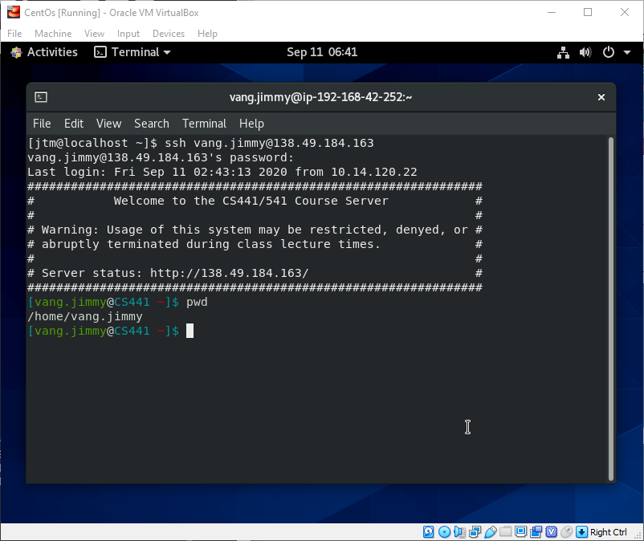

I fork the “cs441-examples” git repository here.
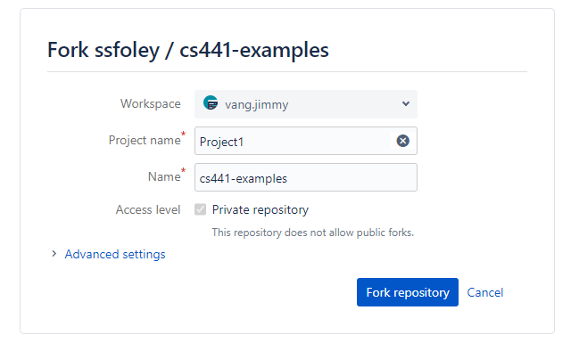

Next, I clone the Fork’d git repository onto the class server.

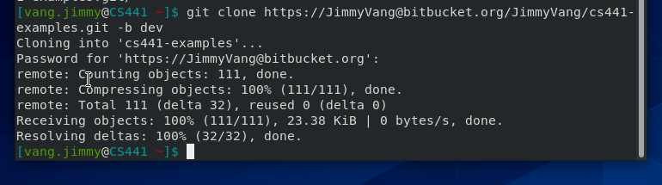

I navigate files and folders on the system using cd and ls. I also copy the hello.c and forever.c files from the folder hello using the command cp.

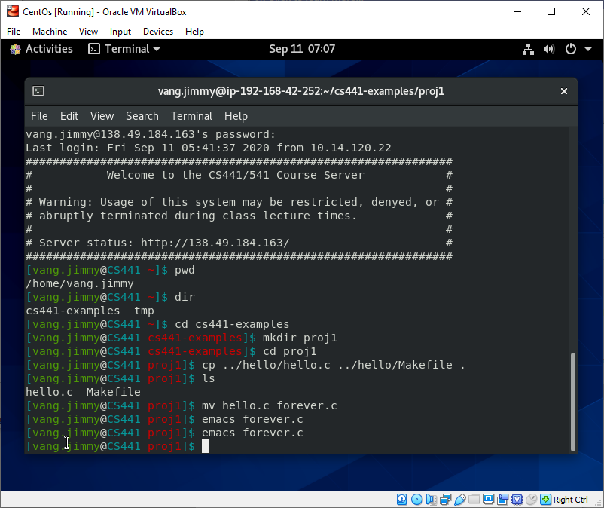

I use emacs to edit the forever.c file.

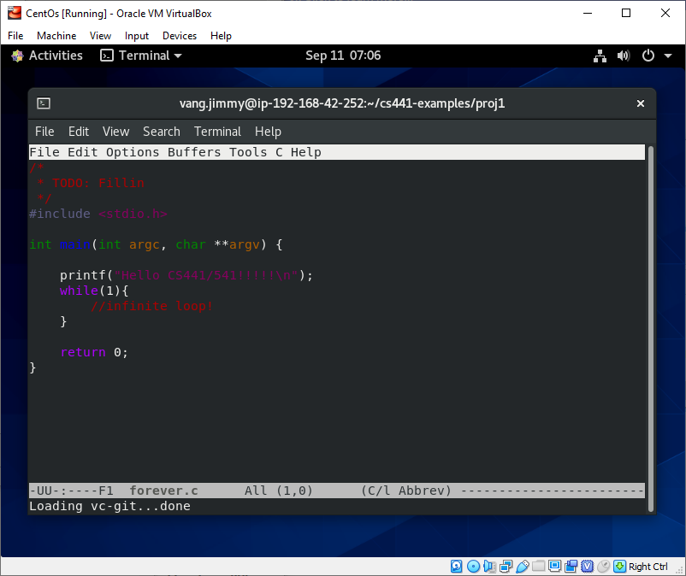

I use cat to print out the changes to forever.c file.

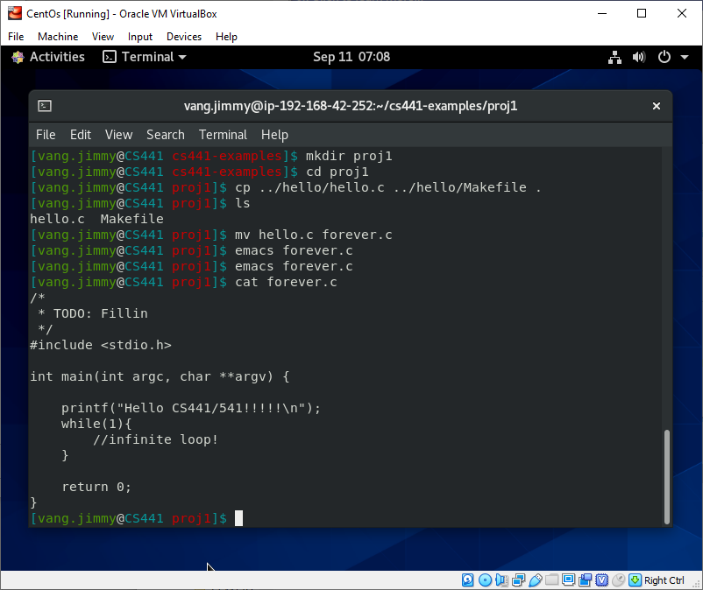

I use emac and to edit Makefile then use cat to view the changes to Makefile.
Also, ran the command make to compile and finish the rest of the changes to the repository.

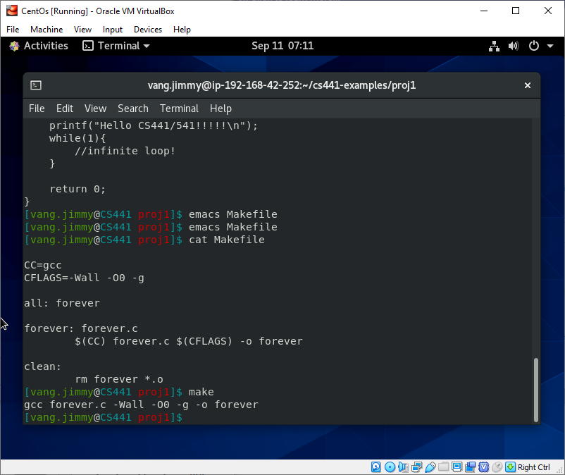

I use git to add the changes.

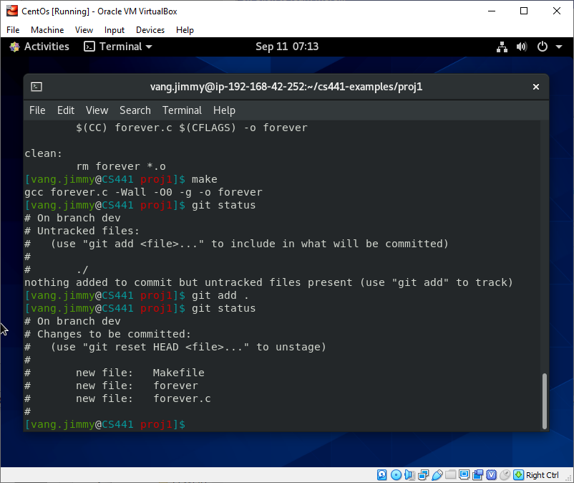

I use git to commit the changes.

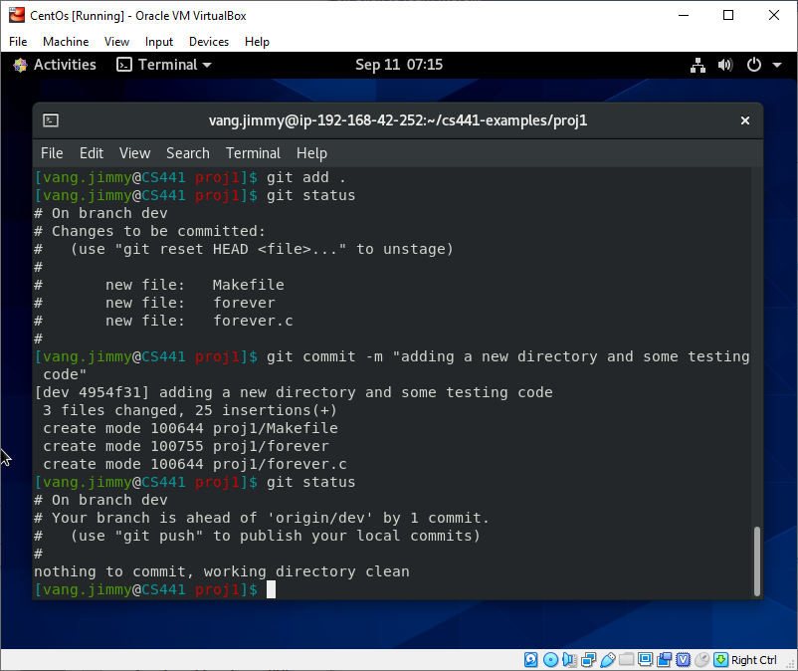

I use git to push the changes onto the dev branch of the repository.

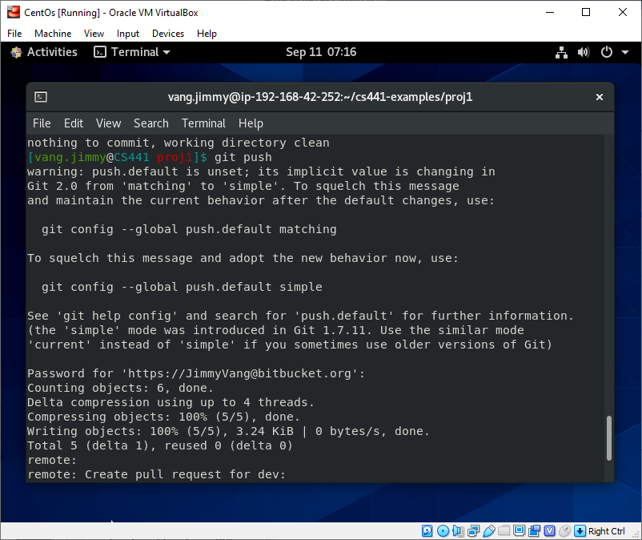

I use git status to comfirm that the push has succeeded.

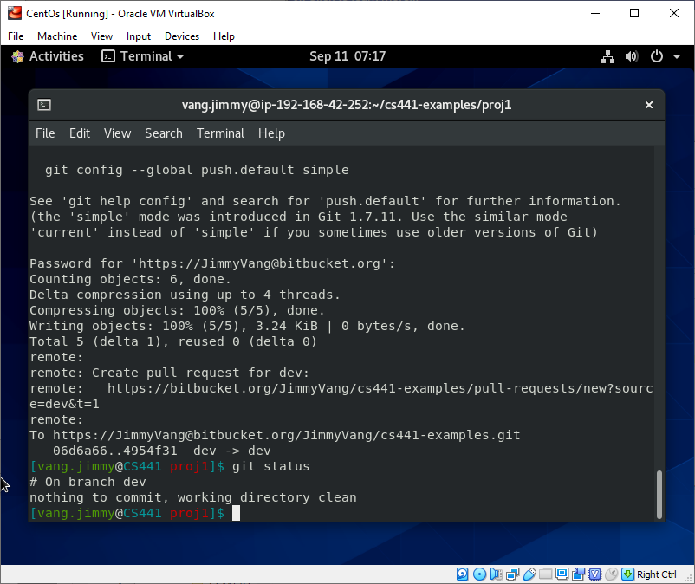

These are screenshots of me playing with the process management. (fg, ps, kill and sleep)

I run the compiled forever.c file as processes and use the command ps to view the processes that are running.

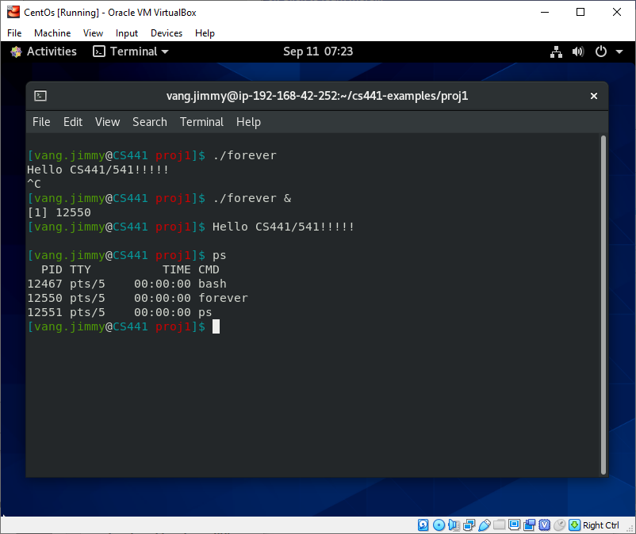

I run more forever.c processes and use ps to view them all.

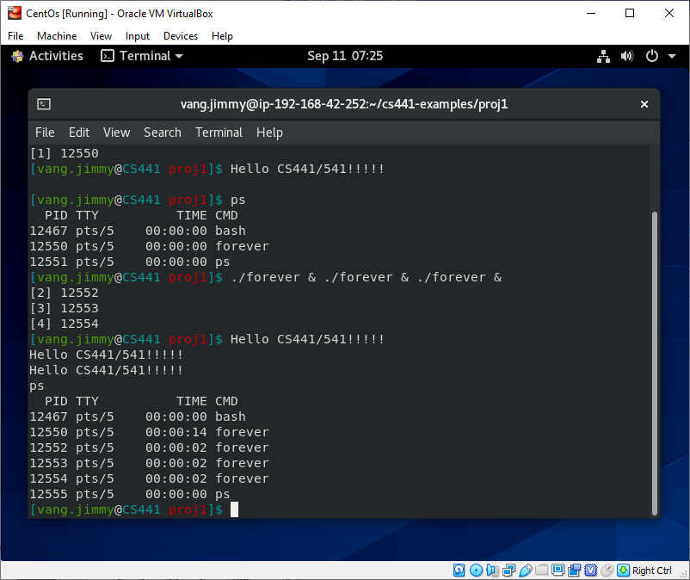

I run the kill command and use ps to check if the processes I ran the command kill on were killed.

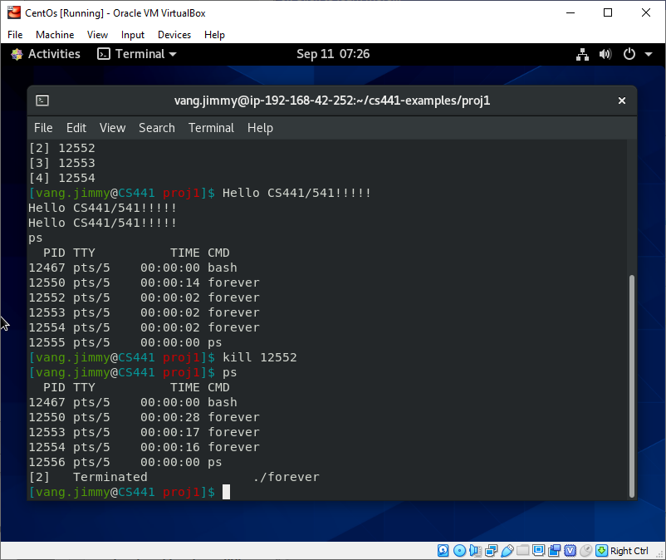

I play around with the command sleep and use ps to check proceses.

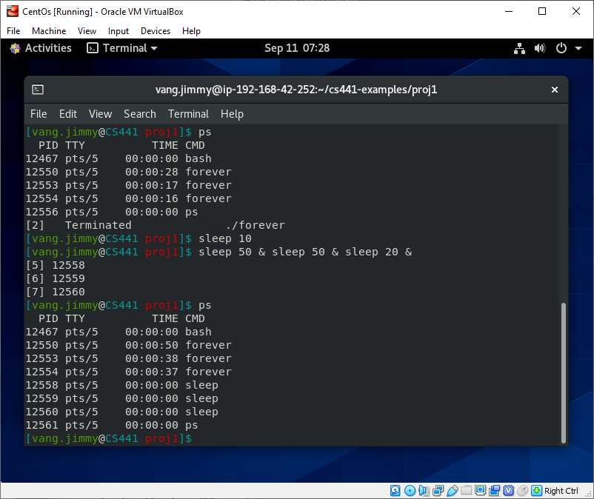

I use the fg command, which then brings one sleep program with 20 seconds into the foreground.

The sleep program finishes after 20 seconds and I use ps to see if the programs are finished and gone.
After about 50 seconds, I check the other background sleep programs with ps and see that they have finished running.

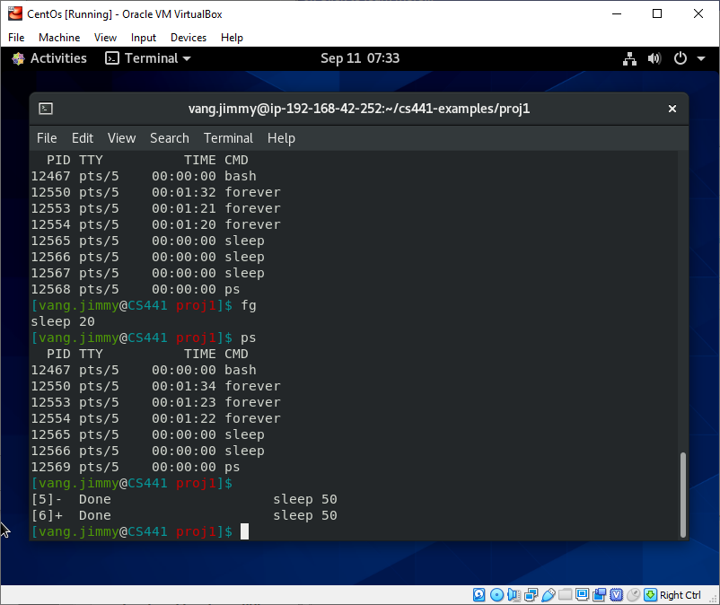

Lastly, I execute the command top. I see all of the processes that are currently running on the CentOS VM and a bunch more information about the OS.

